
Delhi Public School, Hapur
English Rhyme Recitation Competition
RESULTS
Session-2025-26
Classes: Balvatika -1A/B, 2A/B & 3A

Student Name | Class & Sec. | Position | Photo
Aadvik Dixit | Balvatika -1A | 1st | 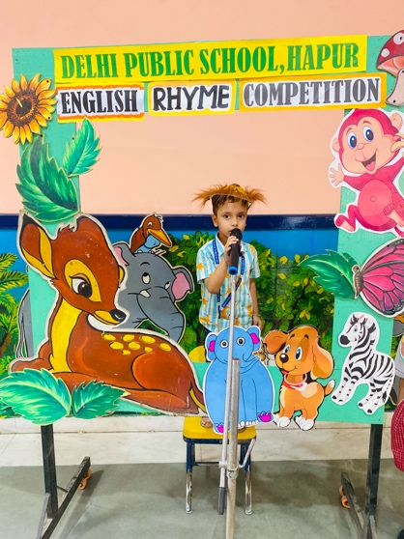
Hridyansh Saini | Balvatika -1A | 1st | 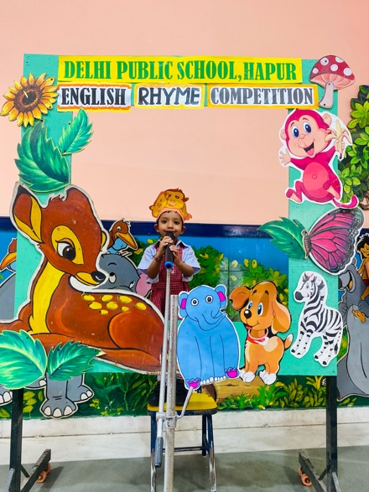
Anidita Singh | Balvatika -1A | 2nd | 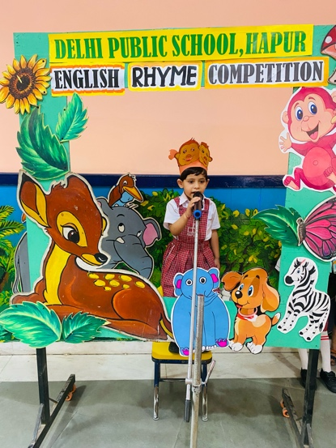
Junaid Ahmad | Balvatika -1A | 3rd | 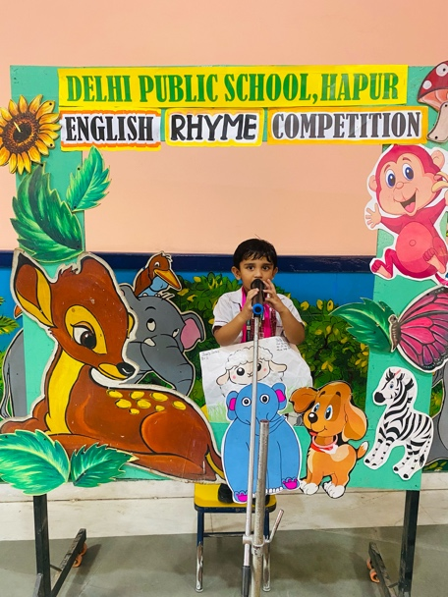
Anwita Dubey | Balvatika- 1 B | 1st | 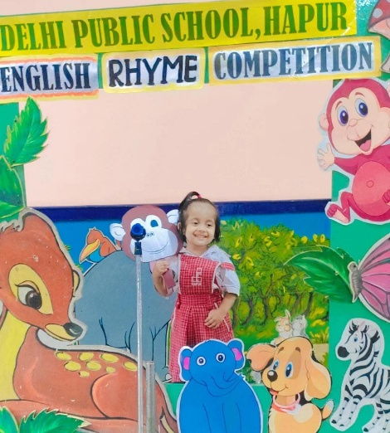
Bhoumik | Balvatika- 1 B | 1st | 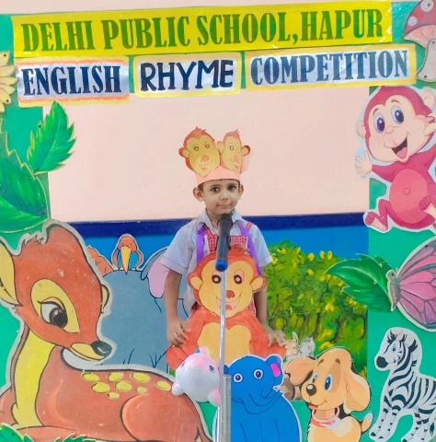
Manushree | Balvatika- 1 B | 1st | 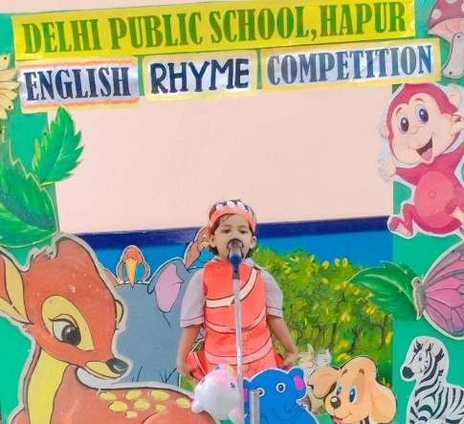
Avik Jindal | Balvatika- 1 B | 2nd | 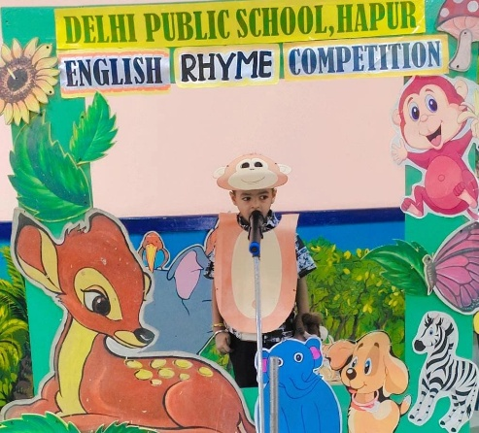
Inaya Asad | Balvatika- 1 B | 2nd | 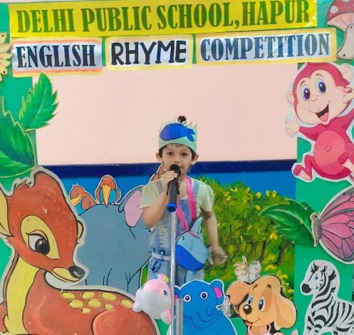
Jhankaar | Balvatika- 1 B | 3rd | 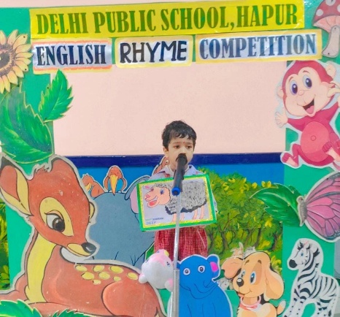
Mo. Umar Ansari | Balvatika- 1 B | 3rd | 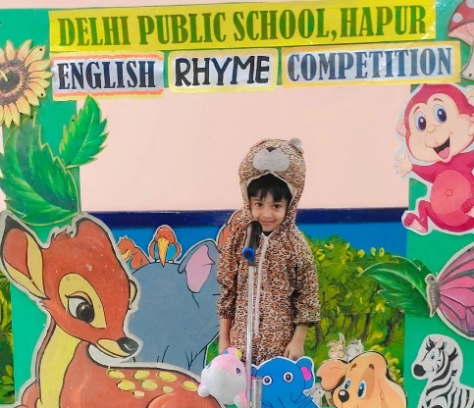
Mo. Abubakar | Balvatika- 1 B | 3rd | 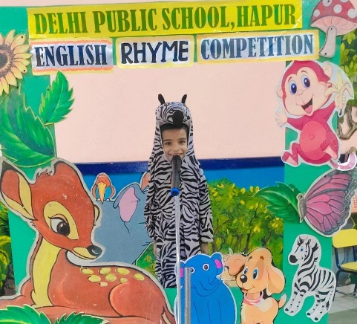
Adishri | Balvatika- 1 B | Consolation | 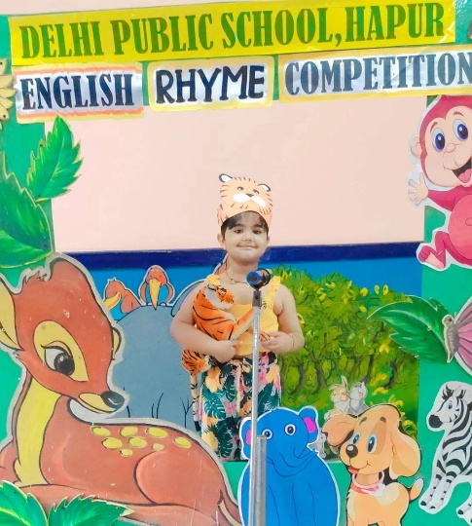
Anvya | Balvatika- 1 B | Consolation | 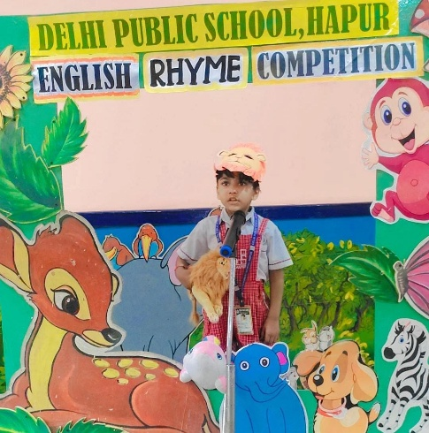
Monisha chauhan | Balvatika- 1 B | Consolation | 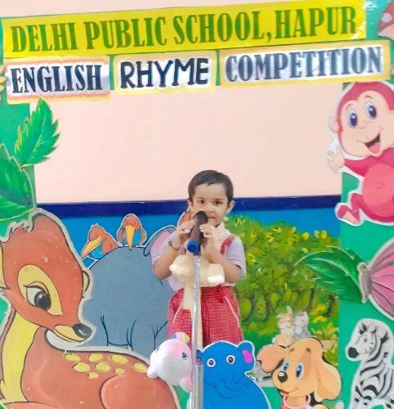

Student Name | Class & Sec. | Position | Photo
Rahil Khan | Balvatika-2 A | 1st | 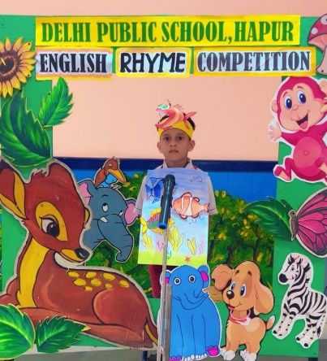
Rudraksh Tyagi | Balvatika-2 A | 1st | 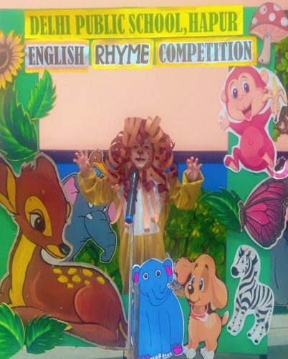
Atharv Sharma | Balvatika-2 A | 2nd | 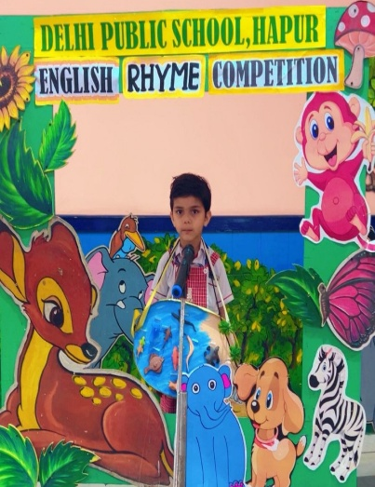
Mayra | Balvatika-2 A | 2nd | 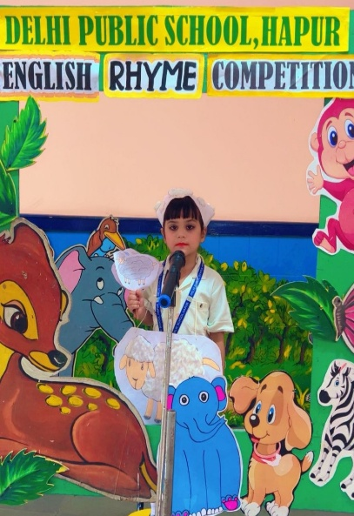
Lavisha Goel | Balvatika-2 A | 3rd | 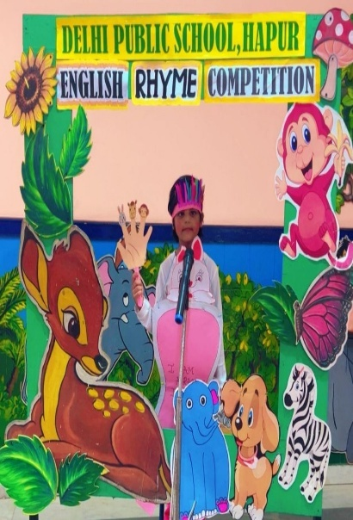
Kaviyansh Aryan | Balvatika-2 A | 3rd | 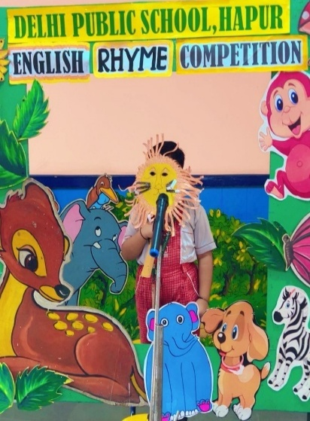
Aadhya Paliwal | Balvatika-2 A | Consolation | 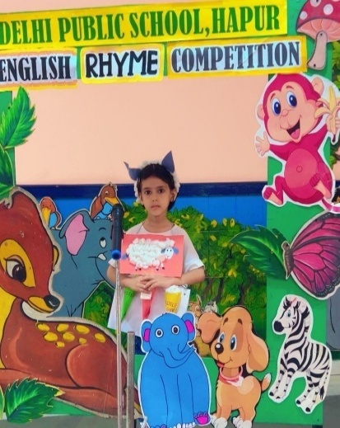

Hiba Chaudhary | Balvatika-2 B | 1st | 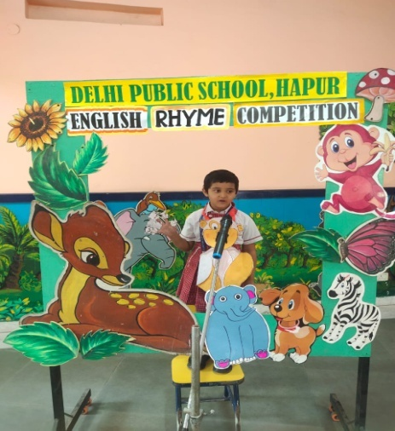
Charvi | Balvatika-2 B | 1st | 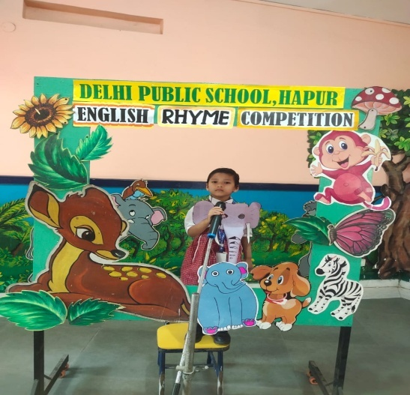
Anvay Tyagi | Balvatika-2 B | 2nd | 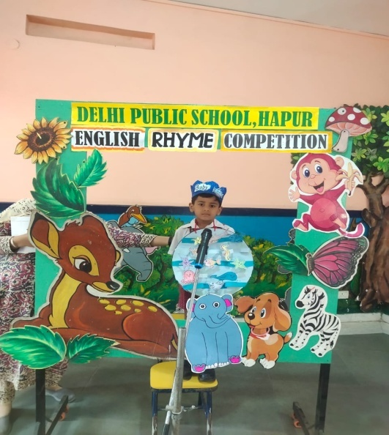
Prerna | Balvatika-2 B | 3rd | 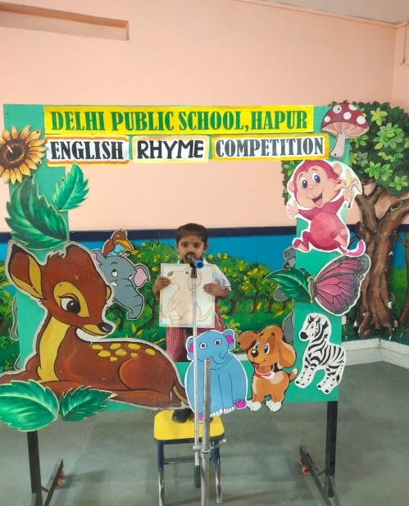
Shiza Ansari | Balvatika-2 B | 3rd | 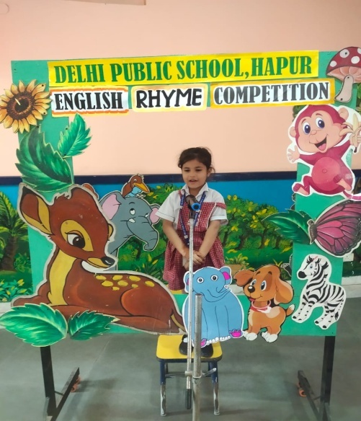
Lavishka Pal | Balvatika-2 B | Consolation | 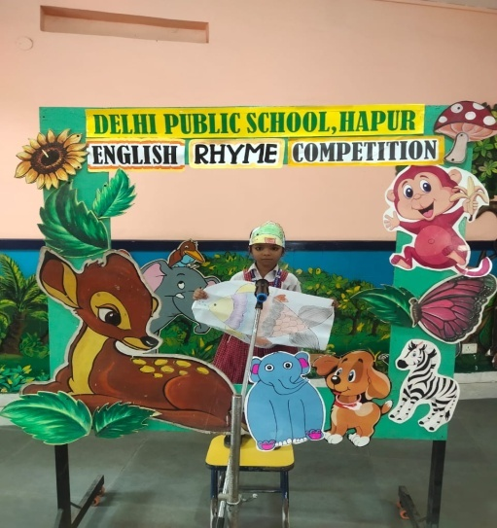
Arnika Choudhary | Balvatika-3 A | 1st | 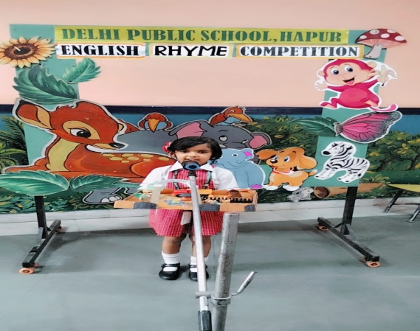
Yohana Singh | Balvatika-3 A | 1st | 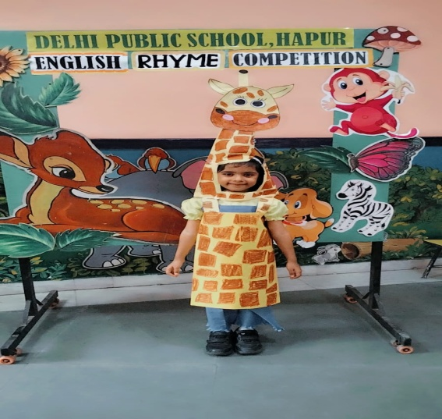
Divishka Tomar | Balvatika-3 A | 1st | 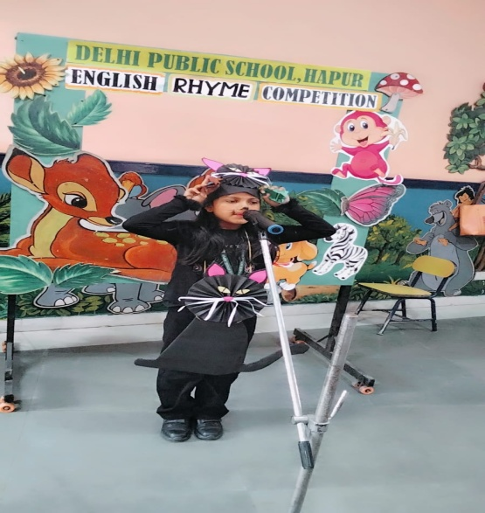
Aarvi | Balvatika-3 A | 2nd | 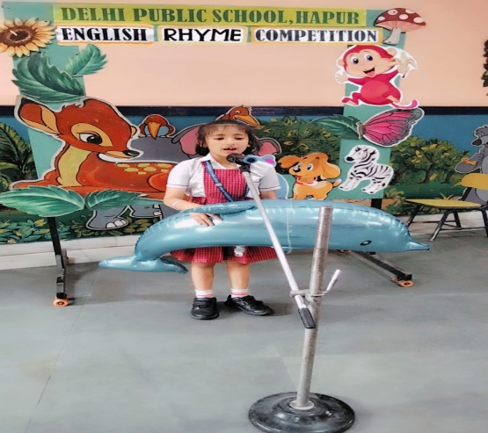
Karunya Bharadwaj | Balvatika-3 A | 2nd | 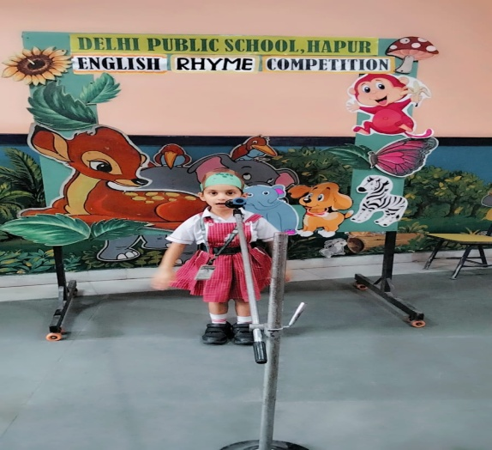
Prabhveer Singh | Balvatika-3 A | 3rd | 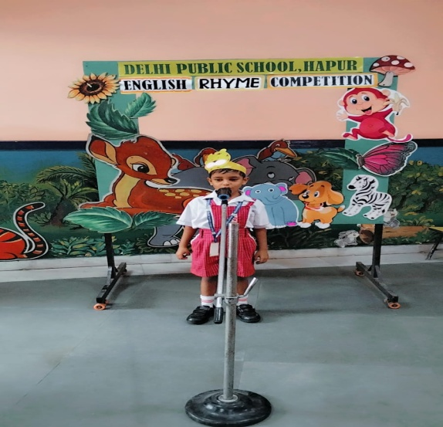
Vedansh Arora | Balvatika-3 A | 3rd | 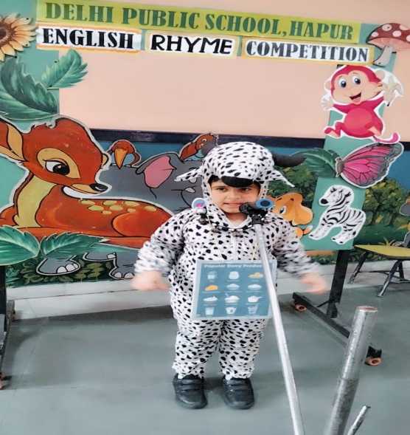
Daivik Bansal | Balvatika-3 A | CONSOLATION | 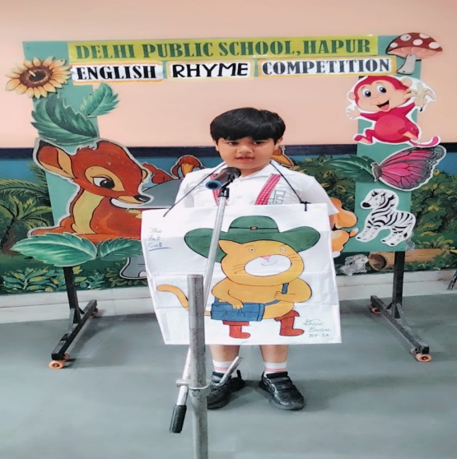
Varnika Pal | Balvatika-3 A | CONSOLATION | 